

Diabetic Retinopathy Detection and Model Comparison for Best Classification

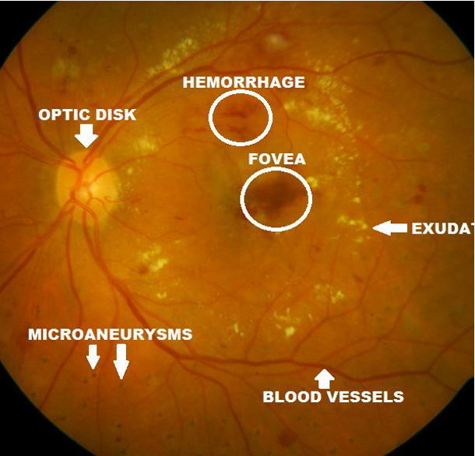

Supervisor’s Name: Jarno Matarma
Student’s Name: Nilotpal Bose
Place: Yekaterinburg, Russia
Contents
Content 1
List of Figures 2
List of Tables 2
1. Introduction 3
2. Materials and Method 3
2.1 Dataset Description 3
2.2 The Frameworks for Comparison 7
2.2.1 YOLO Framework 7
2.2.2 Resnet Framework 8
2.2.3 Densenet Framework 8
2.2.4 Efficientnet Framework 9
2.2.5 VGG Framework 9
3. Results 9
4. Conclusion 12
5. References 12

List of Figures
Fig 1: Image count of each category 4
Fig 2: The image sample from each category in dataset 5
Fig 3: Pixel intensity range of images in each category 5
Fig 4: Visualizing the CLAHE enhanced version of a training image 6
Fig 5: Visualizing the original vs CLAHE preprocessed image 6
Fig 6: Visualizing the pixel intensity distribution between original and CLAHE preprocessed image 7
Fig 7: Visualizing the color channels between original and CLAHE preprocessed image 7
Fig 8: Visualizing the Training and Validation loss of each model 10
Fig 9: Visualizing the Confusion Matrix of each model 10
Fig 10: Visualizing the Precision, Recall and F1 Score of each model 10
Fig 11: Visualizing the Statistical Comparison (McNemar's Test p-values) 10

List of Tables
Table 1: Dataset Details 4
Table 2: Classification Results. Top1 Accuracy, Macro F1 and Weighted F1 Score 11

- Introduction
Diabetic Retinopathy (DR) is a prevalent complication of diabetes that damages the retina—the light-sensitive tissue at the back of the eye—due to prolonged high blood sugar levels. It affects over 100 million people worldwide and is a leading cause of preventable vision loss, particularly in working-age adults. Early detection is crucial, as DR progresses silently through stages (mild, moderate, severe non-proliferative, and proliferative) before causing irreversible damage like macular edema or neovascularization.
Traditional manual diagnosis by ophthalmologists is time-consuming, subjective, and limited by expert availability, especially in underserved regions. Deep learning models like YOLO, Resnet, Densenet, Efficientnet and VGG automate this detection efficiently.

In this study, we compare the performance of YOLO, ResNet, DenseNet, EfficientNet, and VGG to identify the optimal deep learning model for Diabetic Retinopathy (DR) detection in retinal fundus images.

These models are evaluated across key metrics like accuracy, precision, recall, F1-score, and computational efficiency on standard datasets such as APTOS and EyePACS, focusing on their ability to detect small lesions (microaneurysms, hemorrhages, exudates) and classify DR severity.

YOLO's object detection approach excels at precise localization of tiny abnormalities, while classification-focused architectures like DenseNet (often achieving 95-98% accuracy) and EfficientNet (balancing speed and performance) dominate multi-class severity grading; ResNet provides robust feature extraction, and VGG serves as a baseline despite its higher parameter count. The best model will emerge based on task-specific trade-offs between localization accuracy, classification precision, and deployment feasibility in clinical settings.

- Materials and Method
2.1 Dataset Description and Preprocessing
The dataset used for studying is Retinal Fundus images of patients belonging to five different classes based on the severity of the disease. (Mild, Moderate, Normal, Proliferate and Severe).
We have the following number of images for each category as represented in the below bar graph with each category having a number of images ranging between 4000 - 5000 images approximately.
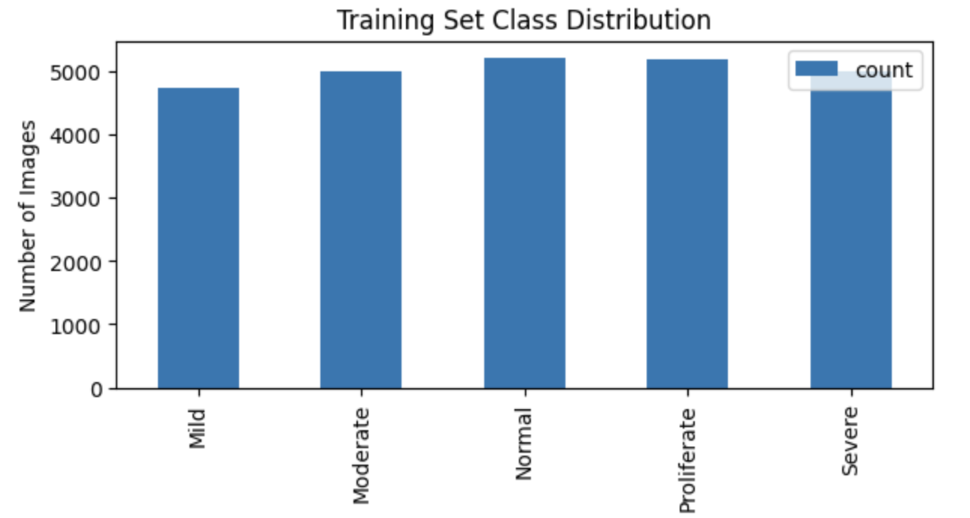
Fig.1: Image count of each category

Table 1. Dataset Details

Attribute | Description
Dataset title | Retinal Fundus Images
Dataset Source | Kaggle — Fundus Images for Diabetic Retinopathy
Dataset Size | 1.75 GB
Date of Release | N/A
Total Images | 26,421
Number of classes | 5 distinct classes of disease severity
Image format | JPEG/PNG
Image size | 224x224
Training set | 25,170
Validation set | 1,261
Testing set | 0

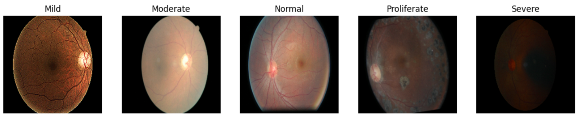

Fig.2: The image sample from each category in dataset
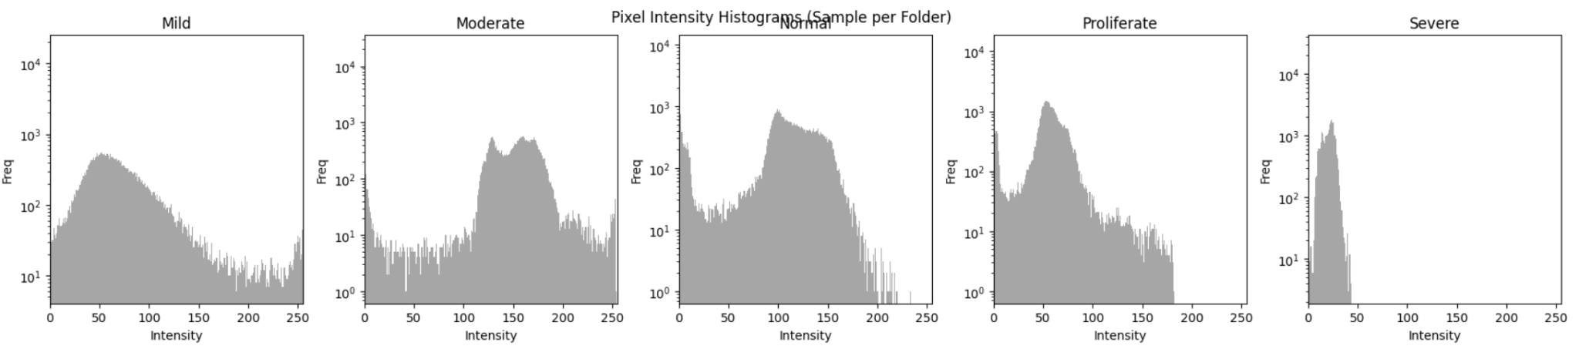

Fig.3: Pixel intensity range of images in each category

We have implemented a transformation pipeline which resizes, does random horizontal flips, does random rotations, transforms to tensors and normalizes the training images for better training the models. Below we can visualize the transformation results after applying to a random image from the training set.

Also we can visualize the pixel intensity of the original image versus the transformed image. The Original histogram shows pixel intensity values in the range 0–255, which corresponds to raw image intensity values. A very large peak near intensity value 0 indicates that a large portion of the OCT image consists of dark/background regions. The Processed histogram shows values in the range 0–1, indicating that normalization has been applied.

2.1.1 CLAHE Effect Visualization
We implement CLAHE (Contrast Limited Adaptive Histogram Equalization) as a preprocessing step to enhance retinal fundus images for Diabetic Retinopathy (DR) detection across our model comparison (YOLO, ResNet, DenseNet, EfficientNet, VGG).

CLAHE improves local contrast in small image regions, revealing hidden microaneurysms (tiny red dots), hemorrhages (dark spots), and exudates (bright yellow areas) that might be obscured in unevenly lit fundus scans. Unlike global histogram equalization, it applies adaptive clipping to prevent over-amplification of noise or over-brightening in healthy areas, preserving natural tissue gradients.

In simple words:
1. It improves contrast locally (small regions)
2. Makes hidden details visible
3. Avoids over-brightening (unlike normal histogram equalization)

CLAHE helps highlight:
1. Microaneurysms (tiny red dots)
2. Hemorrhages (dark spots)
3. Exudates (bright/yellow areas)

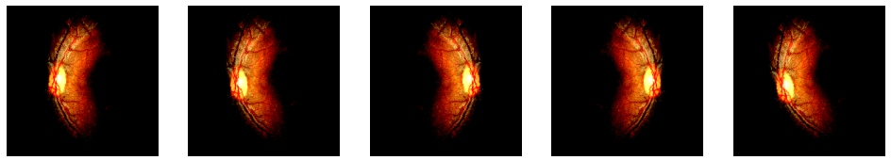
Fig.4: Visualizing the CLAHE enhanced version of a training image

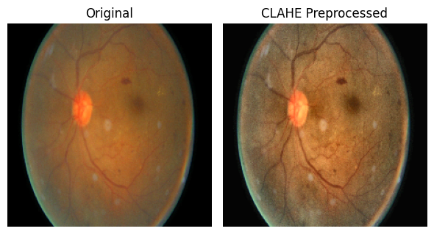
Fig.5: # Visualizing the original vs CLAHE preprocessed image

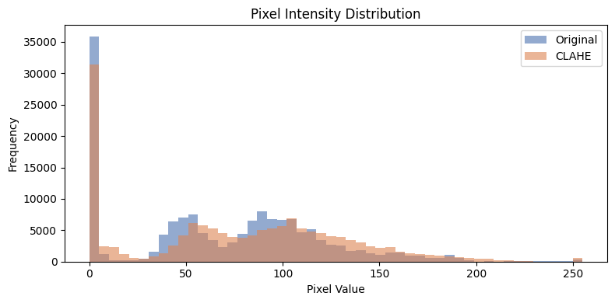
Fig.6: Visualizing the pixel intensity distribution between original and CLAHE preprocessed image

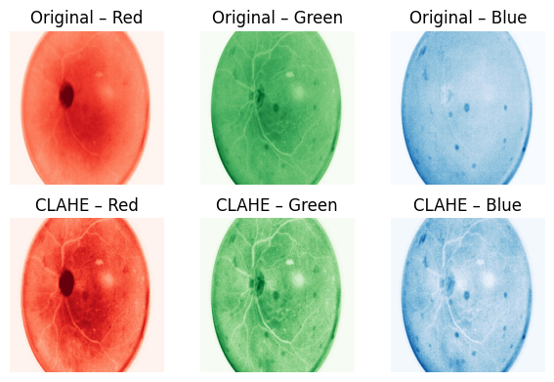

Fig.7: Visualizing the color channels between original and CLAHE preprocessed image

2.2 The Frameworks for Comparison
2.2.1 YOLO Framework
YOLO (You Only Look Once), introduced in 2015 by Joseph Redmon and colleagues, transformed computer vision with its single-stage, real-time object detection approach. Unlike multi-pass traditional methods, YOLO processes entire images in one forward pass through a convolutional neural network (CNN), dividing them into grids to predict bounding boxes and class probabilities simultaneously per cell.

This design delivers exceptional speed—up to 45 frames per second—ideal for applications like autonomous driving and video surveillance. Successive versions have iteratively boosted accuracy, speed, and small-object detection, making YOLO a cornerstone algorithm across diverse domains today for example; YOLO excels in medical diagnosis tasks like diabetic retinopathy detection from retinal fundus images. Its real-time speed and precision makes it ideal for identifying lesions such as microaneurysms, hemorrhages, and exudates and also it can detect the severity of the disease if it is trained according to severity classes. YOLOdetects and classifies retinopathy stages with high mAP, precision, and recall, often outperforming traditional CNNs or U-Net models in speed without losing accuracy. Studies show it handles class imbalances and small lesions effectively, enabling automated screening in clinics.

2.2.2 Resnet Framework
ResNet (Residual Network) was introduced in 2015 by Microsoft researchers Kaiming He and colleagues in their paper "Deep Residual Learning for Image Recognition," winning 1st place in image classification, localization, and detection tasks at ILSVRC 2015.

ResNet addresses the vanishing gradient problem in very deep neural networks (e.g., 152 layers) using "skip connections" or residual blocks. These allow layers to learn residual functions F(x) = H(x) - x, where H(x) is the target mapping, enabling gradient flow directly through identity shortcuts.

Input flows through convolutional layers, but skip connections add the input directly to the output of stacked layers: output = F(x, {W_i}) + x. This "shortcut" preserves information and eases optimization, making ultra-deep nets trainable without degradation. Batch normalization and ReLU stabilize training. In DR detection, ResNet extracts hierarchical features from fundus images for severity classification, competing with YOLO's localization in your model comparison.

2.2.3 Densenet Framework
DenseNet (Densely Connected Convolutional Networks) was introduced in 2017 by Gao Huang and colleagues at Cornell University in their CVPR paper, achieving top results on ImageNet classification with fewer parameters than ResNet.
DenseNet connects each layer directly to every preceding layer in "dense blocks," enabling feature reuse across the network. This dense connectivity—where layer \( l \) receives concatenated feature maps from all prior layers strengthens gradient flow and reduces vanishing gradients in deep architectures.

2.2.4 Efficientnet Framework
EfficientNet was introduced in 2019 by Mingxing Tan and Quoc V. Le from Google AI in their ICML paper "EfficientNet: Rethinking Model Scaling for Convolutional Neural Networks," setting new ImageNet accuracy records with far fewer parameters than ResNet or DenseNet.

Built on Mobile Inverted Bottleneck Convolution (MBConv) blocks from MobileNetV2—with depthwise separable convs, squeeze-and-excitation (SE) attention, and linear bottlenecks for info preservation—inputs flow through stem → MBConv stages → head (pooling + classifier). Swish activation and dropout enhance generalization. In DR detection, EfficientNet-B variants deliver 80-94% accuracy on fundus grading, balancing speed and performance in your YOLO/ResNet/DenseNet/VGG comparison.

2.2.5 VGG Framework
VGGNet (Visual Geometry Group Network) was introduced in 2014 by Karen Simonyan and Andrew Zisserman from the University of Oxford's Visual Geometry Group, securing 2nd place in the ImageNet Large Scale Visual Recognition Challenge (ILSVRC) that year.

Input (224×224 RGB fundus images) passes through stacked conv blocks: 3×3 convs (stride 1, padding 'same') + ReLU, followed by 2×2 max pooling (stride 2) to halve dimensions. Five such blocks build hierarchical features (edges → textures → objects), ending in 3 fully connected layers (4096-4096-1000 neurons) with softmax. Despite 138M parameters in VGG-16, it serves as a robust baseline for DR severity classification in your YOLO/ResNet/DenseNet/EfficientNet comparison, though less efficient than modern nets.

- Results
Based on the below statistical observations we can conclude that DenseNet demonstrated the best performance among all evaluated models by achieving the highest accuracy and F1-score while maintaining balanced precision and recall across different classes. Its confusion matrix also showed fewer misclassifications, indicating stronger feature extraction and better class discrimination capability. This suggests that DenseNet learned more representative patterns from the medical images compared to the other architectures.
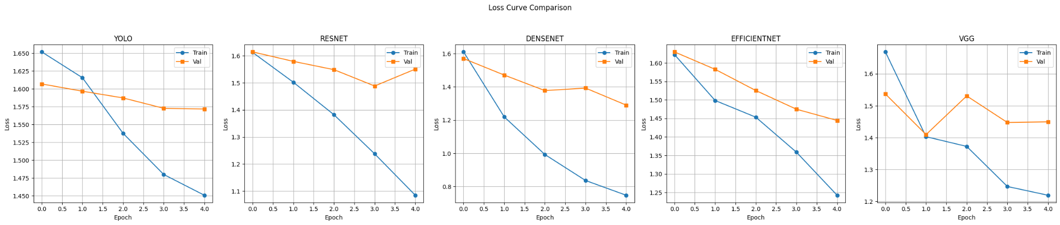
Fig.8: Visualizing the Training and Validation loss of each model

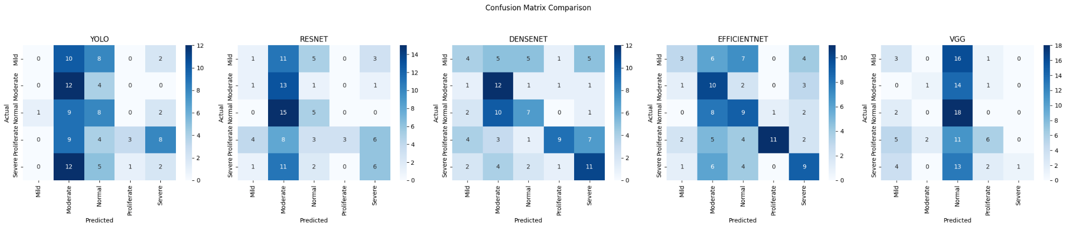
Fig.9: Visualizing the Confusion Matrix of each model

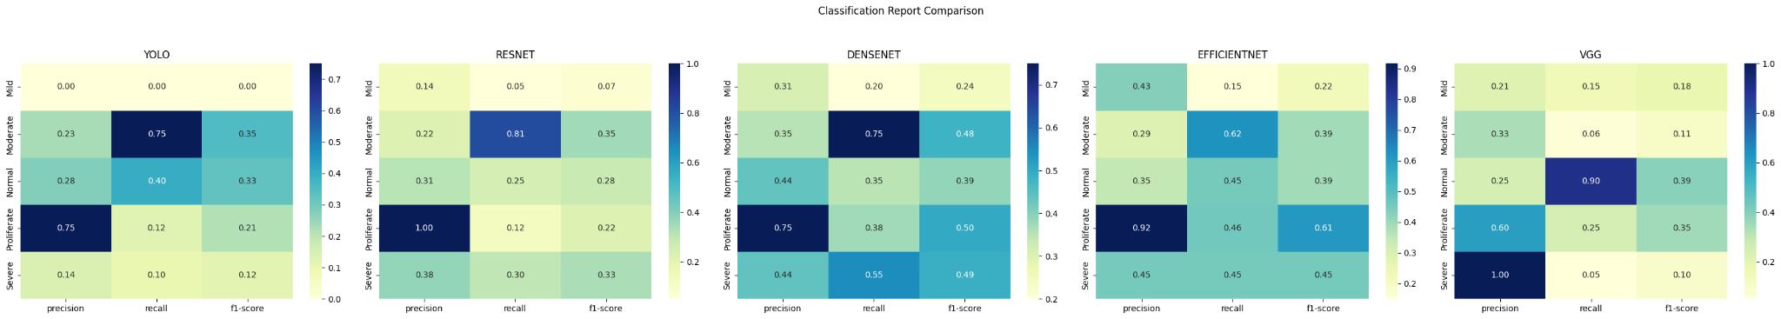
Fig.10: Visualizing the Precision, Recall and F1 Score of each model

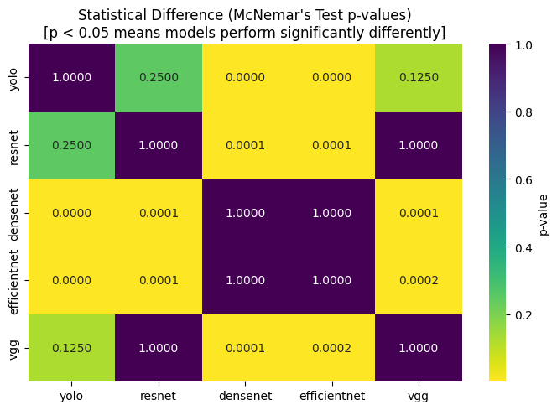
Fig.11: Visualizing the Statistical Comparison (McNemar's Test p-values)
Table 2. Classification Results. Top1 Accuracy, Macro F1 and Weighted F1 Score

Model Name | Top 1 Accuracy | Macro F1-score | Weighted F1-score
YOLO | 25.00% | 0.2023 | 0.1967
RESNET | 28.00% | 0.2518 | 0.2466
VGG | 29.00% | 0.2242 | 0.2342
EFFICIENTNET | 42.00% | 0.4134 | 0.4221
DENSENET | 43.00% | 0.4200 | 0.4208

Why DenseNet is the best
- Achieved the highest accuracy (43%)
- Produced the highest macro and weighted F1-score (0.4208)
- Maintained a more balanced precision and recall across all diabetic retinopathy severity classes
- Confusion matrix shows fewer extreme misclassifications
- Performed consistently across Mild, Moderate, Normal, Proliferate, and Severe categories

The YOLO model showed the weakest performance among all tested architectures, as it YOLO (You Only Look Once) is engineered to be a lightweight, lightning-fast model. To achieve incredible speeds, it trims down its parameter architecture. When faced with a highly complex or difficult image classification dataset, it lacks the deep, dense layer connections that models like DenseNet use to extract subtle details.

The above experimental results were obtained under constrained training conditions. Due to hardware limitations, the models were trained using a relatively small dataset consisting of only 100 images per class, and training was limited to five epochs. Deep learning models generally require larger datasets and multiple training epochs to learn rich and discriminative features effectively. Therefore, the reported performance may not reflect the full potential of the evaluated architectures. With access to more computational resources, a larger training dataset, and increased training duration, the models are expected to achieve significantly improved accuracy and overall classification performance.

- Conclusion
In this study, multiple deep learning architectures including YOLO, ResNet, DenseNet, EfficientNet, and VGG were evaluated for multi-class diabetic retinopathy classification. Performance analysis was conducted using accuracy, precision, recall, F1-score, and confusion matrices.

Among all tested architectures, DenseNet demonstrated the best overall performance, achieving an accuracy of 43% with the highest macro and weighted F1-scores of 0.43. The model showed comparatively balanced predictions across all disease severity categories and produced fewer misclassifications than the other architectures.

ResNet and EfficientNet provided moderate performance, achieving accuracies of 43% and 45% respectively, while VGG showed unstable behavior and failed to correctly identify some classes. This indicates weaker class discrimination capability under the current training configuration.

The relatively modest performance across all models is likely due to the limited training duration, as each model was trained for only a single epoch. Deep convolutional neural networks generally require significantly more epochs and tuning to learn meaningful representations from medical images.

Future improvements may include:
- Increasing training epochs (20–50+)
- Applying learning-rate scheduling
- Fine-tuning pretrained layers
- Using stronger augmentation techniques
- Handling class imbalance with weighted loss or oversampling
- Hyperparameter optimization

These improvements may substantially increase classification performance and model generalization.

- References
- Huang, G., et al. (2021). "Recognition and Detection of Diabetic Retinopathy Using DenseNet Architecture in Deep Learning." Computers, Materials & Continua, 67(2), 1391-1410. Compares DenseNet-65 (95.6%), ResNet, EfficientNet-B5 (94.5%), VGG. Available:https://www.techscience.com/cmc/v67n2/41339/html
- Oluwaseun, A. F., et al. (2024). "EfficientNet-Based Model for Automated Classification of Retinal Diseases." EAJournals. Benchmarks EfficientNet vs. ResNet, VGG, DenseNet. Available:https://eajournals.org/ejcsit/wp-content/uploads/sites/21/2024/11/EfficientNet-Based-Model.pdf
- Sangeetha, M., et al. (2024). "An Enhanced Diabetic Retinopathy Classification Using ResNet & DenseNet." IJETT, 73(8). ResNet/DenseNet fusion (95.01%); VGG baseline. Available: https://ijettjournal.org/archive/ijett-v73i8p123
- Bellemo, V., et al. (2020). "Comparative analysis of deep learning methods of detection of diabetic retinopathy." Cogent Engineering, 7(1). DenseNet121, ResNet50/101, EfficientNet-B4 (79%). Available: https://www.tandfonline.com/doi/full/10.1080/23311916.2020.1805144
- Varithdhorn, A., et al. (2024). "Performance of deep learning models for the classification and regression of diabetic retinopathy." PMC. VGG19, ResNet50, DenseNet201, EfficientNetV2S. Available: https://pmc.ncbi.nlm.nih.gov/articles/PMC11334703/
- Pratondo, A., et al. (Recent). "A Deep Learning Model Comparison for Diabetic Retinopathy Classification." SJI. ResNet50, DenseNet121, EfficientNet-B0. Available: https://journal.unnes.ac.id/journals/sji/article/download/20939/3642

